Synapse Stuff
Seung Lab

Here we have a classic synapse (as Benjamin D. SIlverman calls them).
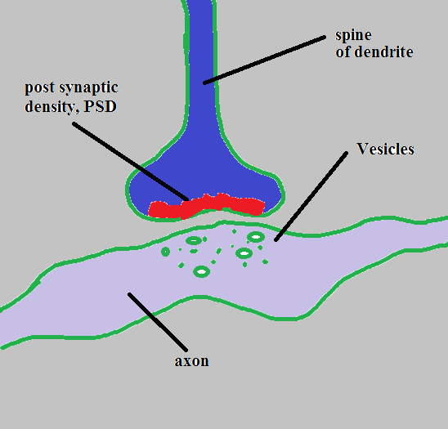
KEY:
- The red is the PSD
- The Dark BLUE is the spine head/dendrite
- The Green Dots and circles are vesicles
- Lastly the Light Purple is the axon

Here we have the hand type synapse (as Benjamin D. SIlverman calls them).
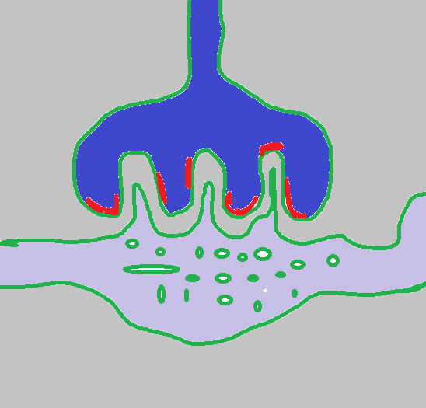
In this example we have a contiguous synapse in which they have the same PSD but they are not continuous. All of these PSD should be given the same segment ID in your segmentation process (though again, this assumes that they connect to the same PSD within another slice).

Here we have the little straggler synapse (as Benjamin D. SIlverman calls them).
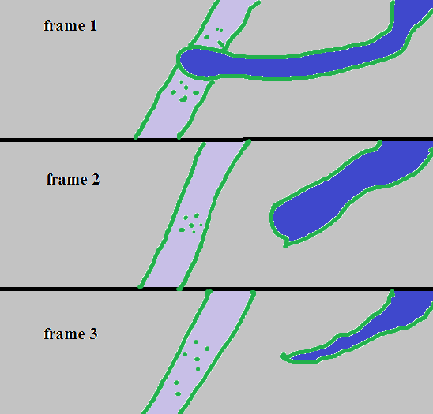
Unfortunately there is no PSD to be found in this example. In this case there is a problem with how the slices/frames were cut and the PSD is not shown. Given that you are an expert tracer you can tell that this is a synapse but unfortunately you can’t label it. You will run into these cases often once you get the eye for the synapse. You will also find cases in which there is a very small amount of PSD - maybe one slice.

Here we have a pancake synapse (as Benjamin D. SIlverman calls them).
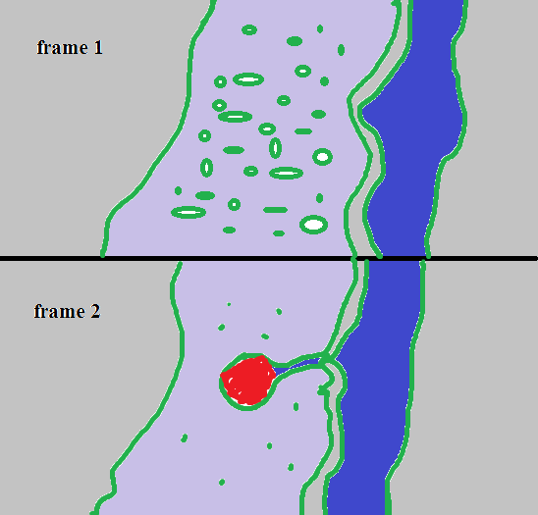
In this example we have the axon being infiltrated by a spine head. This case comes up often and is similar to the little straggler. This situation can happen when the spine acts like a hat to the axon. I have drawn it in side view for y'all to see a different variant. This can also happen with the spine underneath the axon. Anyways, this pancake is a PSD that is squished and cut in a way that is wider than it’s other counterparts. Go ahead and annotate the segment in a wide manner.

Here we have an example of (as Benjamin D. SIlverman calls them) the slide synapse.
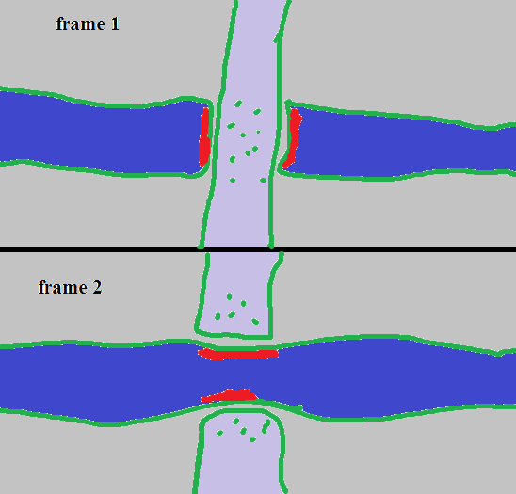
In this example the axon is comin’ on down and it’s synapsing with the wall/tube/shaft/not-spine-part-of-a-dendrite. (Which can totally happen.) The important thing to take note of is that even though the PSD is split they are still one segment ID in your annotation process. In a lot of cases you might night be given frame/slice 2 and you’ll have to imagine it.

When tracing a PSD we decided that it’s best to trace about half way through to the boundary. This sentence might seem a little vague so I will attempt to show you with a picture.
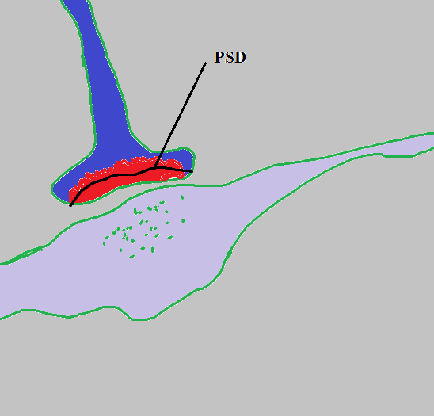
In this picture of a classic we have a dark line cutting across the PSD like a hamburger style roll. Below this line we would not trace any more segmentation for when we are doing ground truth of axons and dendrites and things.

